UNIT 1
ELECTRICITY

In everyday life we are surrounded by gadgets, appliances and machines run by electricity. It seems that every facet of human endeavor depends on them.
First mention of electricity goes back to 600 B.C. when a Greek philosopher noted that amber, rubbed with cloth, attracts light particles. In 1600 A.D. a British physician, Gilbert, published a study of “electric” behavior in several materials. 150 years after, Benjamin Franklin introduced the concept of “positive” and “negative” electricity, and in 1752 showed that lightning and electricity are the same. Later in the century, Coulomb formulated his laws for forces between charged bodies.
Work of several intellectual giants during the 19th century influenced on the knowledge and uses of electricity:
- Volta invented the electric pile (battery)
- Oersted, Ampere, Faraday and Henry discovered electromagnetism and related phenomena
- Morse invented the telegraph
- Bell invented the telephone
- Edison and Swann invented electric arc lights and incandescent lamps
- Edison and Westinghouse invented electric motors and generators
- fundamental studies of electromagnetic wave radiation by Maxwell and Hertz led to radio experiment by Marconi
In the early years of the 20th century new models of the atom increased the understanding of electricity. World War II and the post-war period produced a surge of unprecedented creativity. Revolutionary discoveries and inventions resulted in creating modern-day marvels: television, radar, space communications, computers, and low-cost, consumer electronics. Innumerable electrical products based on transistors, integrated circuits and microelectronic chips, are used in almost every field of activity today.

facet – aspekt, strana
endeavor – nastojanje
physician - liječnik
amber – jantar
phenomena – pojave
electric arc light – lučna svjetla
incandescent lamp – žarulja sa žarnom niti
fundamental – temeljan, osnovni
surge – veliki val
unprecedented – besprimjeran
marvel – divota, čudo
innumerable – bezbrojan
UNIT 2
ELECTROMAGNETISM

Electromagnetism underlies a wide range of phenomena – from the wiggle of a compass needle to the X-rays. Electromagnetism effects include: the “static” forces that electric charges and currents exert on one another, the radio waves for worldwide communications, the light we see by, the gamma rays generated in stars and particle accelerators, etc.
In 1864 James Maxwell conceived his electromagnetic theory of light which is described in his set of equations. The theory predicted that oscillating electric currents would produce electromagnetic waves traveling at the speed of light. In 1887 Hertz's experiment verified this prediction.
But in the 20th century, Einstein's explanation of the photoelectric effect showed that the generation and absorption of light is best described in terms of streams of wave-packets, or photons, each of which contains an amount of energy precisely related to its frequency.
Today, quantum electrodynamics provides us with a formulation which unites classical electromagnetic theory with quantum mechanics. For example, we learn that charged particles repel and attract one another by the constant exchange of virtual photons.

underlie – obuhvaćati
wide – širok
range – raspon
exert – djelovati na
conceive – zamisliti, shvatiti
oscillate – titrati, oscilirati
verify – dokazati, potvrditi
explanation – objašnjenje
in terms of – u uvjetima
stream – niz, slijed, struja, tok
contain – sadržavati
amount – količina
precisely – točno
related – odgovarajući, povezan
repel – odbijati
exchange – izmjena
virtual - prividan
UNIT 3
ELECTRIC CHARGES; ELECTRICAL CONDUCTIVITY

All charged particles can be divided into two classes such that all members of one class repel each other, while attracting members of the other class. Fundamental property of electrical charge is its existence in the two varieties that were named positive and negative.
Electric current is caused by the motion of charge carriers. According to their ability to conduct current, materials are divided into electrical insulators and electrical conductors. Both material properties depend on the mobility of atomic particles – charge carriers. In electrical conductivity we can find examples over the whole range from “good conductor” to “good insulator”, and some substances can change their conductivity, depending on conditions such as their temperature.
The metals are the best conductors that we know of. It’s a result of a fact that metal atoms easily loose one or two outer electrons. These free electrons wander trough the whole crystal lattice, creating the electric current.

UNIT 4
MATHEMATICS

The three major parts of mathematics are algebra (a symbolic outgrowth of arithmetic), geometry (the study of shape), and analysis (the abstract version of calculus).

Logic is the foundation on which the structure of mathematics is built, but it may also be considered a part of applied mathematics.
Two more examples are statistics (the applied theory of probability) and computer science (the applied theory of combinatory)

Decimal number system is the representation of real numbers in base 10, using digits 0-9 and the radix notation (positional representation of numerical quantity, in which digits appearing in successive positions indicate coefficients of successive integral powers, or place values, of the radix or base). The place values usually decrease from left to right.
The radix point is a dot (or comma - in Europe) used to indicate the transition from nonnegative to negative place value.

UNIT 5
ELECTRONICS

The term “electronics” refers to a large number of different phenomena and devices in which useful electrical effects are achieved trough control of the motion of electrons. These effects were achieved in the early part of this century trough the development of vacuum tubes which made possible the beginning of “the electronic age”. Shockley’s discovery that a similar type of control of electron flow could be achieved in solid materials rather than in vacuum led to solid – state amplifiers, made from germanium and silicon. One of the advantages afforded by the use of solid – state electronic control is the possibility of an enormous reduction in the size of the devices.
Partial list of electronic devices today includes amplifiers, integrated circuits, memories, light–emitting devices and solar cells to convert solar energy into electricity.

UNIT 6
SEMICONDUCTERS

Semiconductors are materials having a resistivity in the range between conductors and insulators. Their conductivity increases not only with temperature but is also affected by the presence of impurities in crystal lattice.
An intrinsic semiconductor is a perfect – crystal semiconductor in which each electron needs to be thermally excited by high temperatures or strong electric fields.
An extrinsic semiconductor is one whose conductivity depends on the presence of impurities and on the type and concentration of impurity.
Donor impurities are atoms that have more valence electrons than are required to complete the bonds with neighboring atoms. The number of electrons is greater then the number of mobile holes and these type of semiconductor is called n – type.
Acceptor impurities are atoms that have fewer valence electrons than are required to complete the bonds with neighboring atoms so they accept electrons to complete the bonds. These semiconductors are known as p – type. The process of adding impurities to achieve desired type of conductivity is called doping.
UNIT 7
TRANSISTORS

Bipolar transistor is a device which provides power or voltage amplification. The three regions of the device are emitter, the base, and the collector. The device is produced when another layer is added to a semiconductor diode to form three layers (two junctions). Normally, the emitter-to- base junction is biased in the forward direction, and the collector-to –base junction in the reverse direction. The direction of the current across the device is always opposite to the flow of electrons. The transistor can be used for amplification, oscillation and frequency conversion.
Unipolar transistor is the field-effect transistor (FET). Current flow through the device is controlled by the variation of the electric field established by a control voltage rather than by variation of the current injected into base terminal like in bipolar transistor. FET exhibit many characteristics of electron tubes but also have small size, low power consumption and mechanical ruggedness. On the basis of structural and functional differences, FET are classified as either junction gate field-effect transistors (JFET) or metal-oxide-semiconductor field-effect transistors (MOS/FET).

amplification-pojačanje
to be biased-biti pristran
wide variety-širok raspon
to differ –razlikovati se
conversion - pretvorba
to inject –ubaciti
moreover-štoviše
junction-gate field-efect transistor-spojni tranzistor s efektom polja
to retain-zadržavati
inherent-vlastiti
low power consumption-mala potrošnja energije
ruggedness-hrapavost

UNIT 9
COMPUTER TECHNOLOGY

Computer technology encompasses hardware, software and communications. Computer hardware includes semiconductors and chips that process and store information, printers and plotters, display and interactive components. Software types are operating systems, software compilers, database management systems and application software. Communications includes the equipment and software to support transmission, translation of information, routing and communication code conversion.
Turn of the century –telephone and tabulating equipment
World War II – secret military code translators and processors
1940s and 1950s –breakthroughs in transistors, integrated circuits
1960s - advances in storage
1970s - large mainframe and minicomputers
1980s – microcomputers, widespread computer technology in the home and office
Computer systems in terms of hardware double in power every three years for the same cost and consume less space and power. Software includes artificial intelligence, expert systems, executive information systems and decision support systems.

to encompass –obuhvaćati
plotters – crtači
routing - usmjerivanje
communication code conversion – pretvorba komunikacijskog koda
feature-svojstvo
tabulating – tabeliranje
mainframe-centralna jedinica
to undergo –prolaziti kroz
terms – uvjeti, u pogledu
feasible - izvediv
recognition – raspoznavanje

UNIT 10
COMPUTERS: STRUCTURE AND FUNCTION

Internal structure of the computer consists of four main structural components:
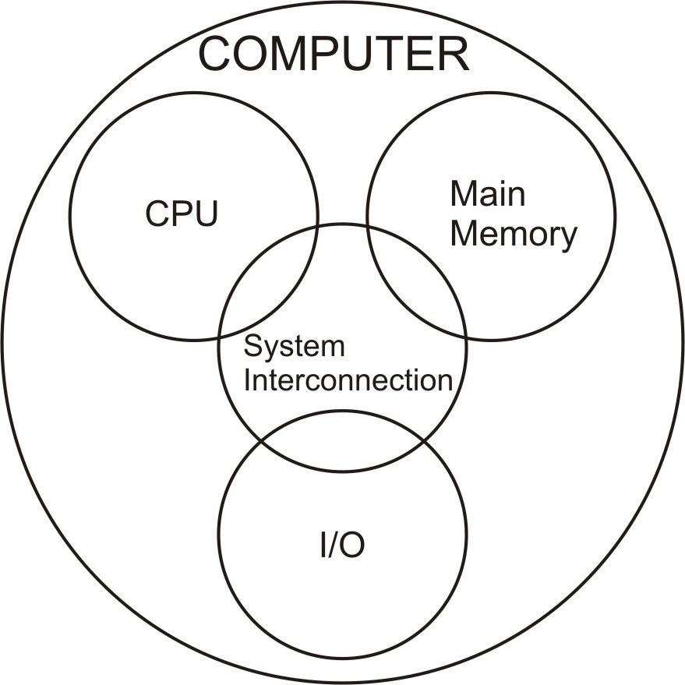
Central processing Unit (CPU): controls the operation of the computer and performs its data processing functions.
Main Memory: stores data
I/O: moves data between the computer and its external environment
System Interconnection: mechanism that provides for communication among CPU, main memory and I/O

CPU consists of these four components:
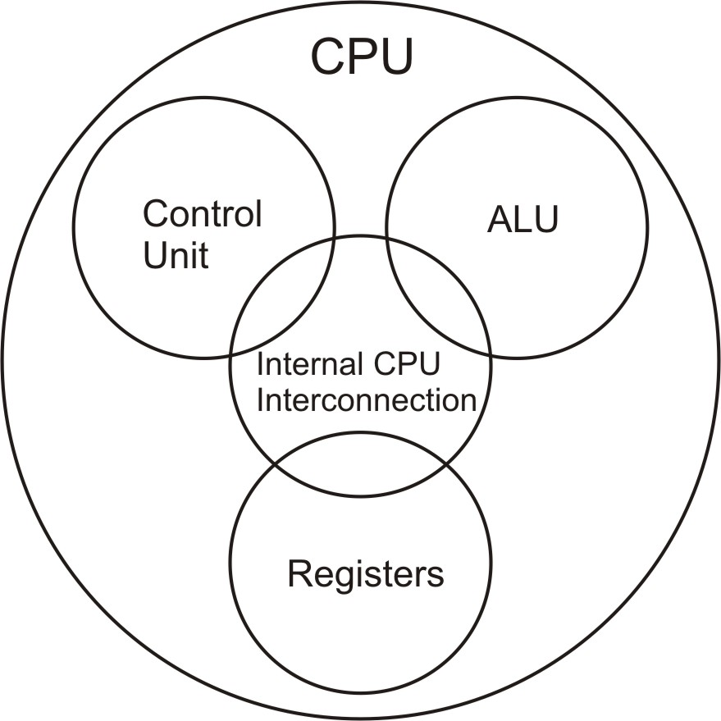
Control Unit: controls the operation of the CPU and hence the computer
ALU: performs the computer’s data processing functions
Registers: provide storage internal to the CPU
Internal CPU Interconnection: some mechanism that provides for communication among the control unit, ALU and registers.

Modern computer design is based on three key concepts:
- Data and instructions are stored in a single read-write memory.
- The contents of this memory are addressable by location, without regard to the type of data contained there.
- Execution occurs in a sequential fashion from one instruction to the next.

The basic function preformed by a computer is program execution. The program consists of a set of instructions stored in memory. The CPU does the actual work by executing instructions specified in the program. The program is executed in two steps: the CPU reads (fetches) instructions from memory one at a time, and it executes each instruction. The CPU exchanges data with memory using two internal registers:
- Memory address register (MAR) - which specifies the address in memory for the next read or write
- Memory buffer register (MBR) - which contains the data to be written into memory or receives data read from memory.
I/O address register specifies a particular I/O device. It is used for the exchange of data between an I/O module and the CPU.

A bus is a communication pathway connecting two or more devices. Multiple devices are connected to the bus, and a signal transmitted by any one device is available for reception by all other devices attached to the bus. A bus actually consists of multiple communication pathways, or lines. These lines can be divided into three functional groups: data, address and control lines. In addition, there may be power distribution lines that supply power to the attached modules.
A bus connecting major computer components is called a system bus.
UNIT 11
COMPUTER PROGRAMMING AND COMPUTER SCIENCE

A computer program is a representation of an algorithm in some well-defined language. Algorithms are abstracts computational procedures for transforming information; programs are their concrete embodiments.

The best programs are written so that computing machines can perform them quickly and so that human beings can understand them clearly. A programmer is ideally an essayist who works with traditional aesthetic and literary forms as well as mathematical concepts, to communicate the way an algorithm works and to convince a reader that the results will be correct. Programs often need to be modified, because requirements and equipment change; programs often need to be combined with other programs. Success at these endeavors is directly linked to the effectiveness of a programmer’s expository skills.
Many subtle techniques are known by which programs can be made to run considerably faster than would be possible with a naïve approach. The quantitative theory of program efficiency is often called the analysis of algorithms.

Computer programming and the analysis of algorithms are subfields of considerably lager discipline called computer science, which deals with all of the complex phenomena surrounding computers.

UNIT 12
DATABASE MANAGEMENT SYSTEM

A database is a collection of information that exists over a long period of time, often many years which is managed by a database management system.
A DBMS (database management system) is expected to:
1. Allow users to create new databases and specify their schema.
2. Give users the ability to query the data and modify the data.
3. Support the storage of very large amounts of data over a long period of time.
4. Control access to data from many users at once without conflicting actions from different users.
Major components of a DBMS:
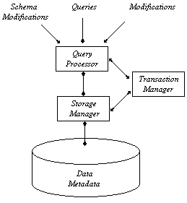
Storage Manager obtains requested information from the data and modifies the information.
Query Processor handles queries and requests for modification of the data.
Transaction Manager is responsible for the integrity of the system (It must assure that several queries running simultaneously do not interfere with each other and that the system will not lose data even if there is a system failure).
Three types of inputs to the DBMS:
1. Queries – questions about the data.
2. Modifications –operations to modify the data.
3. Schema modifications – commands issued by database administrators to change the schema of the database or create a new database.

There are many currents in the database stream today, and they lead the discipline in a variety of new directions. Some of these are new technologies: object-oriented programming, constrains and triggers, multimedia data (video, audio…), or the World Wide Web.

UNIT 13
TELECOMMUNICATIONS

Modern telecommunications began in 1876 with the invention of the telephone by Alexander Graham Bell. Crude electromagnetic devices converted voice to and from electrical signals that could be sent over copper wires from place to place. Initially, human operators enabled manual selection of destinations. Electromagnetic relay switches of increasing sophistication were developed, but since 1947 when Bell Telephone Laboratories invented the transistor, which in turn spawned the integrated circuit, switches have become electronic with steadily increasing speed.

In the underlying technologies, analog representations of information have been rapidly giving way to digital, offering higher quality and performance. In transmission, the development of the optical fiber provides a high-speed replacement for copper wire. And software has become all-pervasive for operating the switches, the networks, and the operations support systems. A revolution is also occurring today in the customer premises equipment – from the simple telephone to multi-function terminals, personal computers, and work stations.

These technologies are increasingly available to anyone so that different networks are proliferating, both private and public. The growing number of network interfaces poses severe challenges to the technologists seeking to facilitate universal networking services; the current direction is toward 'intelligent' networks offering great flexibility, even enabling users to design their own services.

Overall, the societal impact of telecommunications is incalculable. It is a major element which is pacing the development of global society. A major shift is clearly under way in telecommunications, from voice to information, from Universal (Voice) Service to Information Networking. People and their machines will be able to communicate with each other, securely and easily, anywhere, any time. They will communicate in any medium: voice, data, image, or video – and at acceptable cost.

UNIT 14
MOBILE DATA SYSTEMS AND INTERNET TECHNOLOGY

IP (Internet providers) services within mobile networks
Approaching the market of data communications, during the last few years the Public Land Mobile Network (PLMN) operators have begun to deliver data services to their customers. Currently available solutions for data transfer over the Global System for Mobile Communications (GSM) network include Short Message Service (SMS), which allows basic e-mail exchange and traditional low-speed circuit-switched data (CSD), which may be used to access Internet services. Main drawbacks of CSD are the very limited bandwidth capacity and the suboptimal use of the radio interface. A straightforward extension of CSD is high-speed CSD (HSCSD), which increases the transmission capacity by allocating to a single user up to eight CSD channels. However, this solution still makes use of the radio resource in circuit-switched mode, and is therefore poorly optimized for the bursty traffic profile generated by most of Internet applications.
Evolutionary trends
The current development of innovative mobile data services is leading to the coexistence of several wireless overlay networks. On the other hand, the availability of advanced IP mobility protocols makes Internet technology attractive for both interworking between different networks and the definition of new wireless network architectures.

UNIT 15
ISDN

ISDN stands for Integrated Services Digital Network. 'Integrated Services' refers to ISDN's ability to deliver any combination of data, voice, video and fax over a single line. The 'Digital' in ISDN refers to its purely digital transmission, as opposed to the analog transmission of plain old telephone service.
'Network' refers to the fact that ISDN is not simply a point-to-point solution like a leased line.
There are two types of ISDN services available throughout the world: Basic Rate Interface (BRI) and Primary Rate Interface (PRI). BRI service is by far the most common and is typically found in homes and businesses alike. The higher capacity PRI service is a central-site solution for extending applications to large numbers of remote users, who communicate through their BRI connections.
Internet
Internet access is one of the most obvious and popular applications for ISDN. Internet access, however, is really just the beginning of the advantages that come with ISDN's higher speeds, clear connections, and broad communications capabilities.
Telecommuting
Telecommuting – a service providing a complete, remote office or occasional work at home. With a single ISDN line and an ISDN adapter, telephone and fax machine, remote professionals can enjoy the same communications capabilities as office-bound workers.
Education
Just as ISDN has made telecommuting a reality for thousands of professional workers, it is making distance learning a practicality for ground-breaking public and private grade schools, high schools and colleges.
ISDN connections carry voice, video and data
Videoconferencing
The ability to transmit quality video and voice across distances used to require very expensive equipment and costly leased lines that were justified only by the most rigorous needs in the largest of companies.

